Step1: Design the web application.

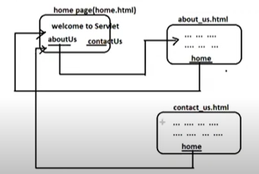

Step2: create the Deployment directory structure of web application.

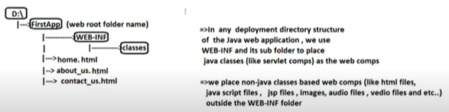

Note:- The web root folder can have any name, can be in any drive and can be in any other folder. But this web root folder name becomes name of web application in the request URL.

Step3: Develop the html files as static web components.

Step4: Deploy the web Application.



Copy the deployment directory structure to <Tomcat_Home>/webapps.

Step5: Start the Tomcat server.

Step6: Test the web application by sending URL from browser.



FileName: home.html

<body style="background-color:orange">

<h2 align='center' style="color:red"> <u>Welcome to Servlet</u></h2>

<br>

<br>

<br>

<a href="contact_us.html" style="color:blue;text-align:center"><b>Contact Us</b></a>&nbsp &nbsp &nbsp &nbsp

<a href="about_us.html" style="color:blue;text-align:center"><b>About Us</b></a>

</body>

FileName:contact_us.html

<body style="background-color:red">

<h2 align='center' style="color:orange"> <u>A.Sukumar</u></h2>

<h2 align='center' style="color:orange"> <u>S/o A.Subbarao</u></h2>

<h2 align='center' style="color:orange"> <u>Rajaka Street</u></h2>

<h2 align='center' style="color:orange"> <u>Nellore</u></h2>

<br>

<br>

<br>

<a href="home.html" style="color:blue;text-align:center"><b>Home</b></a>

</body>

FileName: About_us.html

<body style="background-color:red">

<h2 align='center' style="color:orange"> <u>I am Faculty.</u></h2>

<br>

<a href="home.html" style="color:blue;text-align:center"><b>Home</b></a>

</body>

